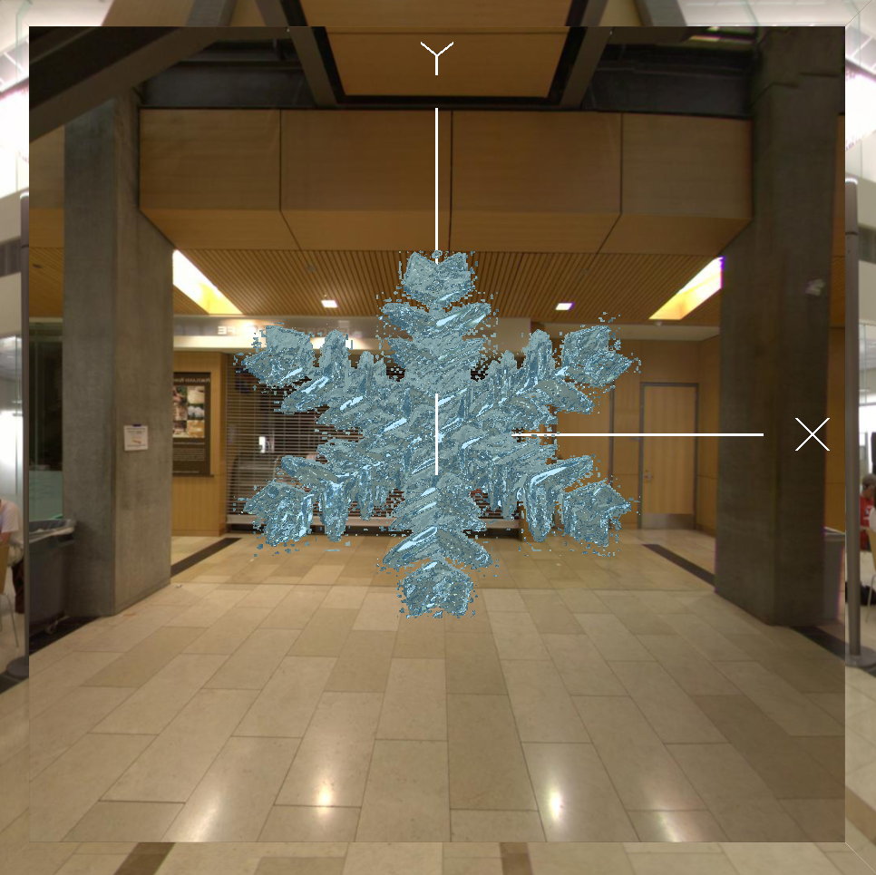

Snowflake

Final Project

Megan McCormick | CS557 | 3/15/20

# Images

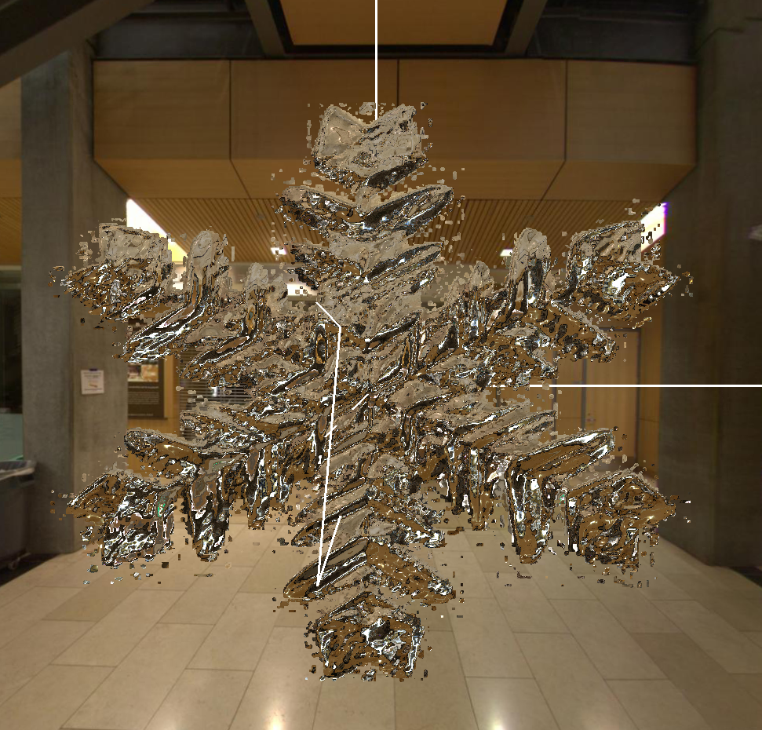

Figure 1: Snowflake in reflective mode to really show Bump Mapping

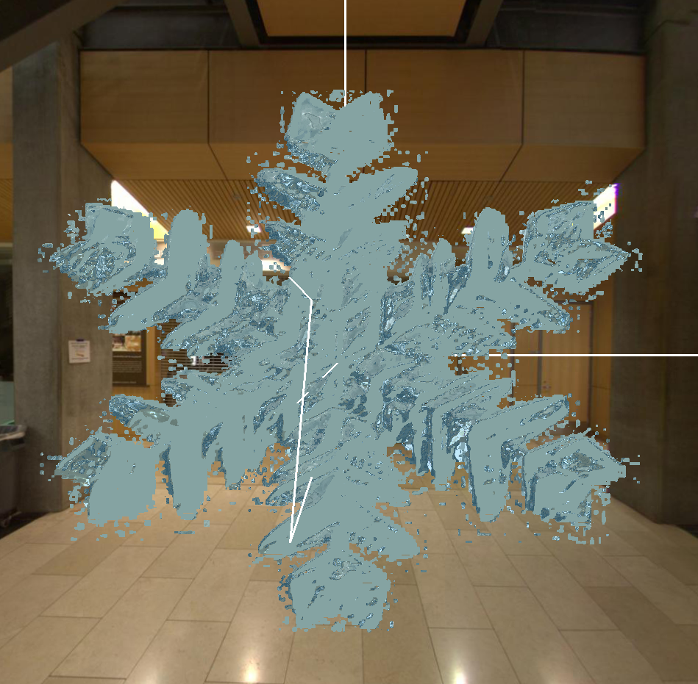

Figure 2: Adjustment of refraction

## Key Code

float refin;

vec3 Normal;

vec3 Light;

vec3 Eye;

Normal = normalize ((texture2D(uNormalTex,vST.st).xyz*2.0 - 1.0));

Light = normalize(Ls);

Eye = normalize(Es);

if ( texture2D(uColorTex,vST.st).b > .99){

discard;

}

if ((texture2D(uNormalTex,vST.st).r)> .9){

refin = uif;

}

else if ((texture2D(uNormalTex,vST.st).r)> .6){

refin = uelseif;

}

else{

refin = uelse;

}

vec3 vRefractVector = refract( Eye, Normal, refin );

vec3 vReflectVector = reflect( Eye, Normal );

vec4 refractcolor = textureCube( uRefractUnit, vRefractVector );

vec4 reflectcolor = textureCube( uReflectUnit, vReflectVector );

refractcolor = mix( refractcolor, BLUE, .40 );

gl_FragColor = vec4( mix( refractcolor, reflectcolor, uMix ).rgb, 1. );

## Video Link

## <https://media.oregonstate.edu/media/t/0_uv21uc88>

## Comments

This project took a lot of time to get it right. Originally, I started with a snowflake object and then implemented bump mapping using a normal map but it would flatten my snowflake object and there was no bump mapping. It also altered the color which wasn’t Ideal. Then I tried to debug my bump mapping on a quad and it worked like a dream, I didn’t want the quad to be there though because it should be a snowflake. A friend of mine suggested I try and “cut out” around the snowflake. Thus I was able to utilize discard to cut out the snow flake!